UID EX 5 – Task Analysis
Name : Abhinandan ER
Roll no: 240701006

Task Analysis
Task Analysis is the process of breaking down how a user completes a food order in an online food ordering application. It helps identify each action the user performs from placing an order to tracking delivery and post-order activities.
Key Aspects of Task Analysis
• Identifying the steps involved in placing a food order.
• Understanding decision points (payment success/failure).
• Analyzing tracking and support interactions.
• Improving user experience by reducing errors and delays.

Task Breakdown for Online Food Ordering System
Step 1: Place Order
• User selects food items.
• Clicks on “Place Order”.
Step 2: Confirm Order
• User reviews selected items.
• Confirms the order details.
Step 3: Payment Verification
• System checks if payment is successful.
If Payment Successful:
→ Order confirmation screen is displayed.
If Payment Failed:
→ Error message shown.
→ User retries or changes payment method.
Step 4: Order Confirmation Screen
• Displays order ID and estimated delivery time.
Step 5: Track Order
• User selects “Track Order”.
• System sends real-time status updates.
Step 6: Live Tracking
• Shows order status:
- Preparing
- Picked up
- En route
- Delivered
Step 7: Need Help? (Decision Point)
• If user faces issues → Contact support/chat.
• If no issues → Continue process.
Step 8: Rate & Review
• User can rate food and delivery service (optional).
Step 9: Reorder / Continue Browsing
• User may reorder same items.
• Or continue browsing the app.
Step 10: End
• Process completes successfully.

User Flow – Online Food Ordering Application
User Flow represents how users move from ordering food to tracking and completing the process.

User Flow Sequence
Start
→ Select Food Items
→ Place Order
→ Confirm Order
→ Payment Successful?
If No:
→ Show Error
→ Retry/Change Payment
If Yes:
→ Order Confirmation Screen
→ Track Order?
If Yes → Send Status Updates → Live Tracking
Need Help?
If Yes → Contact Support/Chat → Back to Tracking
If No → Rate & Review (Optional)
→ Reorder / Continue Browsing
→ End

OUTPUT:
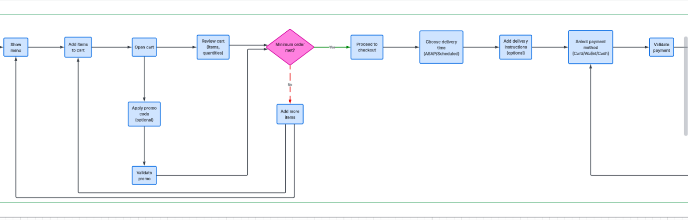


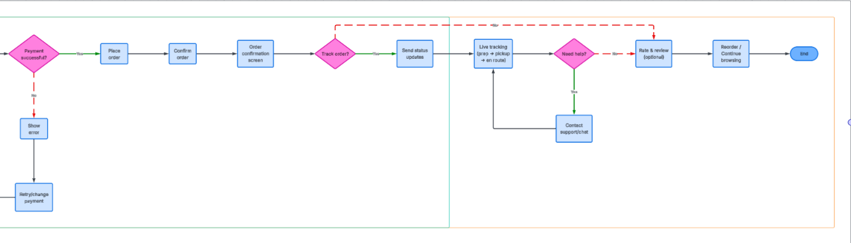
-------------------------------------------------------END------------------------------------------------------------------

